INTERNSHIP PROJECT REPORT
on
“Pan-India Route Optimization and Navigation System”
“GeoRoute”


SUBMITTED BY
SHRUTI PURI

UNDER THE GUIDANCE OF
Ms. Suchitra Choudhary

Institute for Systems Studies & Analyses (ISSA)
Defence Research and Development Organisation (DRDO)
Ministry of Defence, Government of India.

CERTIFICATE
This is to certify that the Internship/Training Report titled "Pan-India Route Optimization and Navigation System”, conducted from 08 JUNE 2026 to 20 JUNE 2026 submitted by SHRUTI PURI as part of the requirements for the B.Tech degree in the Department of Computer Science Engineering at MAHARAJA AGRASEN INSTITUTE OF TECHNOLOGY is an original record of the candidate's work carried out under my supervision.
I hereby declare that, to the best of my knowledge and belief, this submission represents the candidate's own work. Furthermore, it does not include any content that has been substantially accepted for any other degree or diploma from a university or other institute of higher learning, except where appropriate acknowledgments are provided in the text.

Ms SUCHITRA CHOUDHARY
ISSA, DRDO
DECLARATION
I hereby declare that this submission is my own work and to the best of my knowledge and belief, it contains no material that has been previously published or authored by another individual. Furthermore, it does not include any content that has been substantially accepted for the award of any degree or diploma from any university or other institution of higher learning, except where due acknowledgment has been appropriately made within the text.

Signature
SHRUTI PURI

ACKNOWLEDGEMENT

I would like to extend my heartfelt gratitude to Ms. Deepakshi Shah, Director of the Institute for Systems Studies & Analyses (ISSA) Laboratory, Defence Research and Development Organisation (DRDO), for granting me the invaluable opportunity to undergo training at this esteemed organization. This experience allowed me to gain exposure to the Research and Development environment and become familiar with Simulation technologies.
I am deeply grateful to Ms SUCHITRA CHOUDHARY for her insightful guidance and support throughout the training.
Lastly, I wish to express my appreciation to all members of the ISSA group for their constant encouragement, unwavering support, and dedication, which made my training experience truly enriching.

SHRUTI PURI Ms SUCHITRA CHOUDHARY
Computer Science Engineering (Mentor)
2rd Year

ABOUT THE ORGANIZATION
Defence Research & Development Organisation (DRDO)

The Defence Research & Development Organisation (DRDO) operates under the Department of Defence Research and Development, part of the Ministry of Defence. DRDO is committed to enhancing self-reliance in defense systems by designing and developing world-class weapon systems and equipment. These advancements align with the expressed needs and qualitative requirements of the three services: The Army, Navy, and Air Force.
DRDO was established in 1958 through the merger of:
The Technical Development Establishment (TDES) of the Indian Army, The Directorate of Technical Development and Production (DTOP), and The Defence Science Organisation (DSO).
The Defence Research and Development Organisation (DRDO) is a network of more than 50 laboratories, dedicated to advancing defense technologies across various domains. These include aeronautics, armaments, electronics, combat vehicles, engineering systems, instrumentation, missiles, advanced computing and simulation, special materials, naval systems, life sciences, training, information systems, and agriculture. The organization is involved in several major projects, focusing on the development of missiles, armaments, light combat aircraft, radars, electronic warfare systems, and more. DRDO has already achieved significant milestones in many of these technologies. As an agency of the Republic of India, DRDO is responsible for the military's research and development, with its headquarters located in New Delhi. In addition to meeting the military's cutting-edge technology requirements, DRDO's innovations provide considerable spin-off benefits to society at large, contributing to national development and strengthening India's defense capabilities.
Vision
To make India prosperous by establishing a world-class science and technology base, and to provide our Defense Services with a decisive edge by equipping them with internationally competitive systems and solutions.
Mission
- To design, develop, and lead the production of state-of-the-art sensors, weapon systems, platforms, and allied equipment for our Defense Services.
- To provide technological solutions to the Services, optimizing combat effectiveness and promoting the well-being of the troops.
- To develop infrastructure, nurture committed quality manpower, and build a strong indigenous technology base.

Institute for Systems Studies & Analyses (ISSA)

ISSA is involved in System Analysis, Modeling & Simulation for various defence applications pertaining to employment/deployment, tactics & force potential evaluation, tactical/strategic & mission planning etc. We develop war games for all the three Services.
Consequent to the reorganization of the system analysis activities within DRDO, the functions of DSE were redefined and was given the present name, i.e. Institute for Systems Studies & Analyses (ISSA) in the year 1980. In the year 1972, a small group named as Aeronautical Systems Analysis Group (ASAG) was created with an objective to carry out aeronautical systems studies and analyses.
This group was functioning from National Aeronautics Laboratory, Bangalore as a detachment of the Directorate of Aeronautics. In the year 1974, ASAG was converted into a self-accounting full-fledged unit named as Centre for Aeronautical Systems Studies & Analyses (CASSA) and was shifted to the premises of Aeronautical Development Establishment, Bangalore.
From 1974 to 2003, CASSA contributed significantly to a series of systems analysis studies attributed to DRDO HQrs and the Indian Air Force. It contributed into several design and development activities and policy level issues with its objective analyses.
In the year 2003, CASSA was merged with ISSA with an objective to synergies systems analysis activities and wargaming development processes under integrated combat environment. With this, ISSA has emerged as a nodal systems analyses lab and in 2013 ISSA is placed under SAM Cluster with the mandate in the field of Training & Planning Wargames, Integrated Air Defence & EW, Combat Modeling, Simulation System Analysis and computerised Wargame.

Area Of Work
- Modeling, Simulation, Systems Analysis for Defence Application
- Systems Evaluation Studies
- Combat Model Development
- Computer Science and Applications for Defence Modelling & Simulation Domain
- Operations Research and Decision Support Techniques.
Vision
- Transform ISSA into centre of excellence in system analysis, modelling & simulation of defence systems to meet the challenges of the present and future requirements of the armed forces.
Mission
- Conduct system study and develop high quality integrated software for system analysis & decision support in application areas of Sensors & Weapons, Electronic Combat, Land & Naval Combat, Air-to-Air Combat and Air Defence for effective use by DRDO and Services for Design, Mission Planning, Tactics development and Training.

CONTENTS

- INTRODUCTION
  - PROBLEM STATEMENT 4
  - PROJECT GOALS AND OBJECTIVES 5
  - SCOPE DEFINITION 6
  - REPORT OVERVIEW 6

- LITERATURE SURVEY 8
  - LITERARY SURVEY 8
  - THEORETICAL UNDERSTANDING 12

- METHODOLOGY AND SOFTWARE REQUIREMENTS 20
  - METHODOLOGY 20
  - SOFTWARE REQUIREMENTS 21

- IMPLEMENTATION 22
  - BACKEND 22
  - FRONTEND 23

- RESULT AND ANALYSIS 31
- CONCLUSION AND FUTURE PROSPECTS 32
REFERENCES

1. INTRODUCTION
Road navigation systems have become an essential component of modern transportation by enabling efficient route planning and reducing travel time. Most existing navigation applications rely heavily on internet connectivity and cloud-based services to process map data and compute routes. In scenarios where internet access is unavailable or restricted, such systems become ineffective. Furthermore, many commercial navigation platforms depend on proprietary mapping services and online APIs, limiting their suitability for secure or offline environments.
This project proposes the development of an Offline Pan-India Route Optimization and Navigation System, a completely offline web-based routing application capable of displaying a pan-India map and calculating the shortest path between two selected locations without accessing any external service. Unlike conventional navigation systems that retrieve maps from online tile servers and routing information through cloud APIs, GeoRoute stores all required geographical information locally on the host machine. The application renders a satellite basemap using a locally stored GeoTIFF image, loads the complete Indian road network from Shapefiles into a PostgreSQL database with the PostGIS extension, and computes routes using routing algorithms implemented entirely in Java.
The system follows a client-server architecture in which the frontend is developed using Angular and OpenLayers, while the backend is implemented using Spring Boot. The frontend provides an interactive map interface that allows users to place source and destination markers. The backend performs spatial operations such as snapping user-selected locations to the nearest road, extracting only the required road network from the database, and computing the shortest and alternate routes. Since every component executes locally, the application continues to function even when the computer has no internet connectivity.
One of the major challenges in developing an offline routing system is handling large-scale geographical datasets efficiently. A complete road network for India consists of millions of road segments, making it impractical to load the entire graph into memory for every routing request. GeoRoute addresses this challenge by dynamically constructing a routing subgraph around the selected locations. This significantly reduces memory consumption while maintaining routing accuracy. For long-distance routes, the application further optimizes performance by prioritizing major road categories and expanding the search only when necessary.
The project demonstrates the integration of Geographic Information Systems (GIS), spatial databases, graph theory, and modern web technologies to build a scalable and fully offline route planning solution for the Indian road network.

1.1. PROBLEM STATEMENT
Most navigation applications available today depend entirely on internet connectivity for map visualization, location search, and route computation. Maps are generally downloaded from remote tile servers while routing requests are processed by cloud-based services. As a result, these applications become unusable when operating in remote regions, disaster-affected areas, secure government facilities, or isolated organizational networks where internet access is unavailable or intentionally disabled.
Another limitation of existing online navigation systems is their dependence on third-party service providers. Organizations handling sensitive geographical information may not be permitted to transmit location data over public networks due to privacy and security requirements. Commercial mapping platforms also impose licensing restrictions, API usage limits, and recurring operational costs that may not be suitable for long-term deployment.
Developing a completely offline navigation system introduces several technical challenges. The application must locally store and process large geographical datasets, efficiently manage millions of road segments, perform accurate spatial queries, and compute shortest paths without relying on external routing engines. At the same time, the system must provide an interactive user interface similar to modern online mapping applications while maintaining acceptable performance on standard desktop hardware.
GeoRoute addresses these challenges by integrating offline map rendering, local spatial databases, and custom routing algorithms into a single web-based application capable of operating independently of the internet.
1.2. PROJECT GOALS AND OBJECTIVES
The primary goal of GeoRoute is to design and develop a fully offline web-based routing system capable of visualizing a pan-India map and calculating optimal travel routes using only locally stored geographical data.
To achieve this objective, the project integrates an Angular-based frontend with a Spring Boot backend and a PostgreSQL database enhanced with PostGIS spatial capabilities. A natural-color GeoTIFF serves as the basemap, while India's road network is imported from Shapefiles into the database. The application allows users to interactively select source and destination locations, automatically snap those locations to the nearest road, and calculate the shortest path along with multiple alternative routes using the A* search algorithm and Yen's K-Shortest Paths algorithm.
Another important objective is to ensure complete operational independence from external services. After the initial installation and data setup, the application performs all map rendering, spatial analysis, database operations, and routing calculations locally without requiring internet connectivity. This satisfies the security and reliability requirements of organizations operating in isolated or restricted environments.
The project also aims to maintain efficient performance despite the large size of India's road network. Instead of loading the complete network into memory, only the required routing corridor is extracted from the database for each request. This minimizes memory consumption and improves routing speed while preserving route accuracy.
Finally, the project demonstrates the practical use of open-source geospatial technologies to develop a scalable and cost-effective offline navigation solution that can be extended to support additional routing features and geographical datasets in the future.
1.3. SCOPE DEFINITION
The scope of this project includes the development of a fully offline routing application covering the geographical region of India. The application supports interactive map visualization, road snapping, shortest path computation, and the generation of multiple alternative routes using locally stored datasets. All map tiles are generated from a local GeoTIFF image, and the road network is maintained within a PostgreSQL database using the PostGIS extension.
The system is designed primarily for desktop environments where all required software dependencies, spatial datasets, and application components have been installed during an initial setup process. Once configured, the application operates entirely without internet access and performs all computations locally.
The current implementation focuses on road-based routing and does not include real-time traffic information, live road closures, GPS tracking, turn-by-turn voice guidance, address geocoding, or dynamic map updates from online services. Route calculations are based solely on the locally available road network and associated spatial attributes.
Although the application currently supports India, its architecture is sufficiently modular to allow other geographical regions to be incorporated by replacing the underlying spatial datasets and importing the corresponding road networks into the database.

1.4. REPORT OVERVIEW
This report presents the design, implementation, and evaluation of the Offline Pan-India Route Optimization and Navigation System.
Chapter 2 presents a review of existing research and technologies related to offline navigation systems, geographic information systems, spatial databases, and shortest path algorithms. It also discusses the theoretical concepts that form the foundation of the proposed system.
Chapter 3 explains the development methodology adopted during the implementation of the project and describes the software tools, programming languages, libraries, and database technologies used throughout development.
Chapter 4 discusses the implementation details of the system, including the backend services developed using Spring Boot, the frontend interface developed using Angular and OpenLayers, the database design, spatial processing techniques, and the routing workflow.
Chapter 5 presents the results obtained from the completed application and evaluates its performance with respect to routing functionality, offline operation, and overall system behavior.
Finally, Chapter 6 summarizes the work completed during the project, discusses its overall contributions and limitations, and outlines possible future enhancements that could further improve the capabilities of the GeoRoute system.

2. LITERATURE SURVEY
2.1 LITERARY SURVEY
The rapid advancement of Geographic Information Systems (GIS), spatial databases, and graph theory has significantly transformed the field of digital navigation and route planning. Modern navigation systems have become indispensable tools for transportation, logistics, emergency response, urban planning, and infrastructure management. These systems utilize geospatial datasets and graph-based algorithms to determine optimal travel routes between two or more locations. Although commercial navigation platforms provide highly efficient routing services, they predominantly depend on cloud-based infrastructure, proprietary mapping data, and continuous internet connectivity. Such dependencies present limitations in remote areas, high-security environments, military applications, disaster management scenarios, and organizations where internet access is restricted or unavailable. Consequently, considerable research has been directed toward developing offline routing systems capable of performing efficient path computation using locally stored geospatial data.
One of the earliest and most fundamental contributions to shortest path computation was made by Edsger W. Dijkstra in 1959 through the introduction of Dijkstra's Algorithm. The algorithm provides a systematic approach for determining the shortest path from a source node to all other reachable nodes in a weighted graph with non-negative edge weights. Due to its mathematical correctness and guaranteed optimality, Dijkstra's Algorithm has become the foundation for numerous routing applications. The algorithm repeatedly selects the unvisited node with the smallest cumulative cost and relaxes the distances of its neighboring nodes until the destination is reached. Although computationally intensive for extremely large networks, it remains one of the most reliable shortest-path algorithms and continues to serve as the benchmark against which many newer routing techniques are evaluated.
As road networks expanded in size and complexity, researchers recognized the computational limitations of exhaustive shortest-path searches. To improve routing efficiency, Hart, Nilsson, and Raphael introduced the A* (A-Star) Search Algorithm in 1968. Unlike Dijkstra's Algorithm, A* incorporates heuristic information to estimate the remaining distance from the current node to the destination. By prioritizing nodes that appear more promising, the algorithm significantly reduces the search space while still guaranteeing the optimal path when an admissible heuristic is used. In geographical routing applications, the Euclidean or great-circle distance between two coordinates commonly serves as the heuristic estimate. Because of its speed and accuracy, A* has become one of the most widely adopted algorithms in GPS navigation systems, robotics, artificial intelligence, and game development.
While determining the single shortest path is sufficient for many routing applications, practical transportation systems frequently require multiple feasible alternatives. Factors such as road congestion, user preference, accidents, maintenance activities, or personal travel constraints often necessitate more than one route option. This requirement has led to extensive research in K-Shortest Path algorithms, which generate several distinct paths between the same source and destination while minimizing total travel cost. Various approaches, including Yen's Algorithm, Eppstein's Algorithm, and several graph decomposition techniques, have been proposed to efficiently compute multiple shortest routes without repeatedly executing the shortest-path algorithm from scratch. Among these, the implementation provided by pgRouting through the pgr_ksp() function has become particularly valuable for GIS-based applications because of its seamless integration with spatial databases.
The evolution of spatial databases has further accelerated the development of offline navigation systems. Traditional relational database management systems were originally designed to store textual and numerical information and lacked native support for geographic objects. To address this limitation, spatial database extensions such as PostGIS were developed for PostgreSQL. PostGIS introduces specialized geometric data types, including Points, LineStrings, Polygons, and MultiPolygons, along with hundreds of spatial functions for distance computation, topology analysis, coordinate transformation, buffering, intersection, containment, and nearest-neighbor searches. The availability of spatial indexing mechanisms such as GiST (Generalized Search Tree) enables efficient execution of complex geographic queries on datasets containing millions of spatial records.
Another significant contribution to offline routing technology is pgRouting, an open-source extension built upon PostgreSQL and PostGIS. pgRouting transforms a spatial database into a graph-processing engine capable of executing numerous routing algorithms directly within SQL queries. The extension supports algorithms including Dijkstra's Algorithm, A*, K-Shortest Path, Bidirectional Dijkstra, Floyd-Warshall, Driving Distance analysis, Traveling Salesman Problem (TSP), and several network analysis functions. Executing routing operations within the database reduces communication overhead between the application and the database server while allowing efficient utilization of spatial indexes and optimized query execution plans.
The quality and organization of geospatial datasets play an equally important role in route planning systems. Geographic data is generally represented using two primary models: raster and vector data. Raster datasets represent the earth's surface as grids of pixels, making them suitable for satellite imagery, elevation models, and terrain visualization. The GeoTIFF format has become the industry standard for storing georeferenced raster imagery because it combines image information with embedded geographic coordinate metadata. In contrast, vector datasets represent geographic features using mathematical geometries such as points, lines, and polygons. The ESRI Shapefile (.shp) remains one of the most widely adopted formats for storing vector road networks due to its simplicity, compatibility, and extensive support across GIS software platforms. Most offline routing systems combine raster imagery for map visualization with vector road networks for route computation.
Graph theory provides the mathematical foundation for modeling transportation networks. In graph-based routing, road intersections are represented as vertices, while road segments connecting these intersections form the edges of the graph. Each edge is assigned one or more weights representing traversal cost, such as physical distance, travel time, fuel consumption, or road quality. Pathfinding algorithms operate on this graph structure to determine the optimal sequence of edges connecting the source and destination nodes. Proper graph construction, including node generation, edge connectivity, and weight assignment, directly influences routing accuracy and computational efficiency.
Efficient spatial indexing has emerged as another critical research area in GIS. Since road networks covering an entire country may contain millions of road segments and intersections, sequential searching becomes computationally impractical. Spatial indexing structures, particularly the GiST index implemented in PostGIS, organize geographic objects hierarchically to minimize search space during nearest-neighbor queries and spatial joins. These indexing mechanisms significantly reduce response time when locating the closest road segment to a user-selected location or identifying candidate nodes for route computation.
Several government organizations, defense agencies, disaster management authorities, and research institutions increasingly emphasize offline geospatial systems for mission-critical applications. In military operations, internet connectivity may be unreliable or intentionally disabled for security reasons. Similarly, during natural disasters such as floods, earthquakes, or cyclones, communication infrastructure may become unavailable precisely when navigation assistance is most essential. Offline routing systems ensure uninterrupted availability by storing all required geospatial information locally and executing routing algorithms without network dependence.
Despite substantial progress in routing technologies, several challenges remain in implementing country-scale offline navigation systems. Pan-national road networks contain millions of road segments, requiring efficient storage mechanisms, optimized graph generation, scalable indexing strategies, and high-performance routing algorithms. Furthermore, maintaining consistent coordinate reference systems across multiple datasets is essential to ensure accurate spatial analysis and visualization. Researchers continue to investigate graph partitioning, hierarchical routing, parallel processing, and advanced heuristic techniques to improve the scalability of routing systems operating on large geographic datasets.
The proposed project builds upon these established theoretical and technological foundations by integrating PostgreSQL, PostGIS, pgRouting, Spring Boot, and AngularJS into a unified offline routing platform. Unlike conventional navigation systems that rely on proprietary cloud-based services, the proposed solution stores the complete Indian road network locally using Shapefile datasets and visualizes the map through GeoTIFF imagery. Shortest-path computation is performed using Dijkstra's Algorithm and A* Search Algorithm, while pgr_ksp() generates multiple alternative routes according to user requirements. The system is specifically designed to operate entirely offline, making it suitable for secure environments, research applications, educational purposes, and organizations requiring complete control over their geospatial infrastructure.
2.2 THEORETICAL UNDERSTANDING
2.2.1 Geographic Information System (GIS)
A Geographic Information System (GIS) is a computer-based framework used to collect, store, manage, analyze, and visualize geographically referenced data. Unlike conventional information systems that process only textual or numerical information, GIS integrates spatial and attribute data to represent real-world geographical features. GIS combines hardware, software, geographic datasets, and analytical techniques to solve location-based problems. It has become an indispensable technology in transportation planning, disaster management, military operations, logistics, environmental monitoring, urban development, and public administration.
The primary objective of GIS is to answer spatial questions such as where a particular location exists, what is the shortest path between two locations, which roads intersect a given area, which regions lie within a specified distance of a location, and how geographic information can be efficiently visualized and analyzed.
In the proposed GeoRoute system, GIS forms the foundation of the application. A GeoTIFF raster image is used as the offline natural-colour basemap, while India's transportation network is stored as ESRI Shapefile vector data and imported into a PostGIS spatial database for efficient routing operations.

2.2.2 Spatial Data Models
Spatial information is commonly represented using two fundamental data models: raster and vector.
The raster data model stores geographic information as a grid of equally sized cells called pixels. Every pixel contains a value representing information such as colour, elevation, land cover, or satellite imagery. Raster data is particularly suitable for continuous geographical information. In this project, a GeoTIFF raster image provides the natural-colour basemap used for offline visualization.
The vector data model represents geographical features using mathematical geometries. A point represents a single location, a line (LineString) represents roads or rivers, and a polygon represents regions, states, lakes, or administrative boundaries. Vector data provides high positional accuracy while requiring significantly less storage than raster data for linear features.
Since roads naturally consist of connected line segments, the complete Indian road network is represented as LineString geometries stored in an ESRI Shapefile and later imported into PostGIS.

2.2.3 Coordinate Reference Systems (CRS)
A Coordinate Reference System (CRS) defines how locations on the Earth's surface are represented numerically. It specifies the coordinate origin, units of measurement, projection method, and earth model used by a geographic dataset.
When multiple spatial datasets use different coordinate systems, they cannot be accurately overlaid unless transformed into a common CRS. The proposed system standardizes all datasets to the WGS84 geographic coordinate system (EPSG:4326). This ensures that the GeoTIFF imagery, road network, and user-selected locations align correctly during map rendering and routing.
Using a common CRS prevents spatial inaccuracies and allows distance calculations and routing operations to be performed consistently.

2.2.4 Spatial Database Management
Traditional relational database systems efficiently store textual and numerical information but lack specialized support for geographic objects. PostGIS extends PostgreSQL by introducing spatial data types and hundreds of GIS functions.
PostGIS supports geometry types including Point, LineString, Polygon, MultiLineString, and MultiPolygon. It also provides advanced spatial functions for distance calculation, buffering, coordinate transformation, nearest-neighbour search, intersection analysis, and spatial joins.
The GeoRoute application stores the road network inside PostGIS, allowing spatial operations such as nearest-road detection and road geometry retrieval to be executed directly within SQL queries without relying on external GIS software.

2.2.5 Spatial Indexing
A nationwide road network contains millions of road segments. Sequentially searching every road whenever a user selects a location would result in unacceptable response times.
To improve query performance, PostGIS uses Generalized Search Tree (GiST) spatial indexes. A GiST index organizes spatial objects hierarchically according to their bounding boxes, allowing the database to quickly eliminate geometries that cannot satisfy a query.
The routing system uses GiST indexes together with bounding-box operators and K-Nearest Neighbour (KNN) searches to rapidly locate the road segment closest to the user's selected point. Spatial indexing significantly reduces query execution time and enables the application to scale efficiently for large national datasets.

2.2.6 Graph Theory
Graph theory provides the mathematical foundation for road network modelling and routing. A graph is represented as
G = (V, E)
where V represents vertices (nodes) and E represents edges connecting those vertices.
Within a transportation network, road intersections become graph vertices while road segments become edges. Each edge is assigned a weight representing travel cost, which may correspond to distance, travel time, or another routing metric.
Representing the road network as a weighted graph allows mathematical algorithms to efficiently determine optimal travel routes between two locations.

2.2.7 Shortest Path Problem
The shortest path problem involves determining the minimum-cost path between two nodes within a weighted graph. The cost may represent physical distance, estimated travel time, or fuel consumption.
Efficient shortest-path computation is particularly important for a nationwide road network because millions of possible routes may exist between two locations. Modern navigation systems therefore rely on optimized shortest-path algorithms to compute routes within practical execution times.

2.2.8 Dijkstra's Algorithm
Dijkstra's Algorithm is one of the most widely used algorithms for solving the shortest path problem in weighted graphs with non-negative edge weights.
The algorithm begins at the source node and repeatedly selects the unvisited node having the smallest known distance. Distances to neighbouring nodes are updated whenever a shorter route is discovered. The process continues until the destination node has been permanently labelled.
Dijkstra's Algorithm always produces the optimal shortest path but explores many unnecessary nodes when operating on very large road networks. Consequently, although it serves as a reliable baseline algorithm, more advanced methods are often preferred for country-scale routing systems.

2.2.9 A* Search Algorithm
The A* Search Algorithm improves upon Dijkstra's Algorithm by introducing heuristic guidance. Instead of considering only the distance already travelled, A* estimates the remaining distance to the destination.
The evaluation function is
f(n) = g(n) + h(n)
where:
- g(n) represents the accumulated cost from the source node to the current node.
- h(n) represents the estimated remaining cost from the current node to the destination.
The GeoRoute system uses the straight-line geographic distance between coordinates as the heuristic. Since this heuristic never overestimates the remaining distance, A* guarantees an optimal solution while exploring significantly fewer nodes than Dijkstra's Algorithm.
This reduction in search space greatly improves routing performance for large transportation networks.
2.2.10 Yen's K-Shortest Paths Algorithm
Real-world navigation systems often provide several alternative routes rather than only a single shortest path. The K-Shortest Paths problem seeks to determine multiple unique paths between the same source and destination, ordered according to increasing cost.
The GeoRoute application uses Yen's K-Shortest Paths Algorithm, which repeatedly computes alternative routes by modifying portions of previously discovered shortest paths while ensuring that duplicate routes are not produced.
The first route returned is always the globally shortest path. Subsequent routes represent valid alternative paths that differ from earlier solutions while remaining near-optimal.
If the user specifies N alternate routes, the system returns a total of N + 1 routes, consisting of one shortest route and N additional alternatives.
This functionality allows users to compare different travel options while maintaining efficient computation.
2.2.11 pgRouting
pgRouting is an open-source extension for PostgreSQL and PostGIS that provides advanced graph-routing algorithms directly inside the spatial database. Instead of exporting road data into external applications, routing computations are performed using SQL functions executed within PostgreSQL.
pgRouting supports several graph algorithms including Dijkstra's Algorithm, A* Search, Yen's K-Shortest Paths Algorithm, Driving Distance analysis, and many network analysis functions.
Within GeoRoute, the road network stored in PostGIS is treated as a graph where road intersections form vertices and road segments form weighted edges. pgRouting performs shortest-path and alternative-route calculations directly on this graph, reducing application complexity while taking advantage of PostgreSQL's query optimization and spatial indexing capabilities.
2.2.12 GeoTIFF Raster Visualization
GeoTIFF is an extension of the TIFF image format that stores both raster imagery and geographic metadata. Unlike ordinary images, GeoTIFF files preserve information such as geographic coordinates, map projection, and spatial resolution.
The GeoRoute application stores a natural-colour GeoTIFF locally and converts it into standard XYZ map tiles using a Spring Boot tile-rendering service. These tiles are generated entirely offline and supplied to the Angular frontend without contacting any external tile server.
This approach enables realistic map visualization while satisfying the requirement that the system operate completely without Internet connectivity.
2.2.13 Shapefile Road Network
The ESRI Shapefile is one of the most widely adopted formats for storing vector geographic information. A Shapefile dataset typically consists of multiple files including .shp, .shx, .dbf, and .prj, each storing geometry, indexing, attributes, and projection information respectively.
In the proposed system, the Indian road network is stored as a Shapefile. During system initialization, the road geometries and associated attributes are imported into PostGIS, where each road segment becomes an edge within the routing graph.
Using locally stored Shapefiles enables the application to remain fully functional without relying on online mapping services.
2.2.14 RESTful Architecture
Communication between the frontend and backend follows the Representational State Transfer (REST) architectural style.
The Angular frontend sends HTTP requests containing the source coordinates, destination coordinates, routing algorithm, and number of alternative routes. The Spring Boot backend processes these requests, performs spatial analysis using PostGIS and pgRouting, and returns routing information as structured GeoJSON responses.
The REST architecture promotes loose coupling between application layers, simplifying maintenance and future expansion.
2.2.15 Frontend Visualization
The frontend is developed using Angular 17 together with the OpenLayers mapping library. The user interface allows users to interactively explore the offline map, place source and destination markers, select routing options, and visualize multiple computed routes.
Routes returned by the backend are rendered using different colours and styles so that the primary route and alternative routes can be easily distinguished. Since all map tiles originate from the locally stored GeoTIFF, the visualization component operates entirely offline.
2.2.16 Three-Tier System Architecture
The proposed application follows a three-tier software architecture consisting of the presentation layer, application layer, and data layer.
The presentation layer is implemented using Angular 17 and OpenLayers, providing the graphical interface through which users interact with the map.
The application layer is implemented using Spring Boot and contains the business logic responsible for tile generation, nearest-road snapping, routing requests, and communication with the spatial database.
The data layer consists of PostgreSQL with the PostGIS and pgRouting extensions. It stores the GeoTIFF-derived metadata, the imported road network, and performs spatial queries together with graph-routing computations.
Separating the system into independent layers improves modularity, maintainability, scalability, and simplifies future enhancements.
2.2.17 Offline GIS Architecture
A distinguishing feature of GeoRoute is its completely offline architecture. Unlike conventional web mapping systems that depend on cloud-hosted map tiles, online geocoding services, and external routing APIs, GeoRoute performs every operation locally.
The GeoTIFF basemap, Shapefile road network, Angular application, Spring Boot backend, PostgreSQL database, PostGIS extension, and pgRouting library all reside on the local system. After the initial setup, no Internet connection is required for visualization, spatial analysis, or route computation.
This architecture makes the application suitable for defence organizations, disaster management systems, remote field operations, and secure environments where external network access is unavailable or restricted.
3. METHODOLOGY AND SOFTWARE REQUIREMENTS
3.1 METHODOLOGY
GeoRoute was developed using a modular client-server architecture in which the frontend, backend, spatial database, and geographical datasets work together to provide a completely offline routing system. The development methodology focused on ensuring that every component of the application could operate independently of the internet after an initial setup. Rather than relying on external APIs or cloud-based services, all spatial processing, map rendering, and route computation are performed locally on the user's machine.
The overall workflow begins with the preparation of geographical datasets. A natural-colour GeoTIFF file is used as the raster basemap, while the Indian road network is obtained as a Shapefile containing road geometries and their associated attributes. During the initial setup, these datasets are stored locally and remain available for all future executions of the application.
When the backend application starts, Spring Boot initializes the required services and establishes a connection with the PostgreSQL database. The DataLoaderService verifies whether the road network has already been imported into PostGIS. If the required tables are empty, the service automatically reads the Shapefile and extracts each road segment along with its geometric and descriptive information. The imported roads are converted into graph structures consisting of nodes and edges, allowing routing algorithms to process them efficiently. Once the import is complete, the application marks the road network as ready for routing.
The frontend is developed using Angular and OpenLayers. When the user opens the application, Angular loads the user interface while OpenLayers initializes the interactive map. Instead of requesting map tiles from an online provider such as OpenStreetMap or Google Maps, every map tile is requested from the local Spring Boot server. The GeoTiffTileService reads the locally stored GeoTIFF image, extracts the required geographical region corresponding to the requested zoom level and tile coordinates, converts it into a 256 × 256 PNG image, and returns it to the browser. Frequently requested tiles are stored in a local cache to reduce rendering time during repeated map navigation.
After the map is displayed, the user selects the source and destination locations by clicking on the map. Since these locations may not lie directly on a road segment, the coordinates cannot be used immediately for routing. Instead, they are sent to the RoadSnapService, which performs a nearest-neighbour search using PostGIS. The service first limits the search area by creating a small bounding box around the selected point. This significantly reduces the number of road segments that must be examined. The nearest road is then identified, and the selected point is projected onto that road. Finally, the closest endpoint of the road segment is chosen as the routing node.
Once both routing nodes have been identified, the RoutingService begins the route computation process. Loading the complete Indian road network into memory for every request would require considerable memory and processing time. To overcome this limitation, the application dynamically constructs a routing subgraph that contains only the roads surrounding the source and destination. The size of this subgraph depends on the distance between the selected locations. Short-distance routes include all nearby roads, whereas long-distance routes initially prioritize major highways and arterial roads before expanding the search if necessary.
After constructing the subgraph, the routing algorithm searches for the shortest path between the selected nodes. The application supports both Dijkstra's algorithm and the A* search algorithm. A* is used as the default algorithm because it reduces unnecessary exploration by estimating the remaining distance to the destination, thereby improving performance on large road networks. When the user requests alternate routes, Yen's K-Shortest Paths algorithm generates multiple loop-free alternatives while preserving the shortest route as the primary recommendation.
The resulting route initially consists only of graph edges. To display the route correctly on the map, the backend retrieves the complete geometry of every road segment from the database. These geometries are combined into a continuous sequence of geographical coordinates, converted into GeoJSON format, and returned to the frontend through the REST API.
Upon receiving the GeoJSON response, Angular passes the route data to OpenLayers, which renders the route as coloured vector overlays above the GeoTIFF basemap. Each route is displayed using a different colour, allowing the user to distinguish between the primary route and alternative routes. The route panel simultaneously displays the estimated travel distance and travel time calculated by the routing algorithm.
The overall methodology ensures that every stage of the routing process—from map visualization to shortest path computation—is executed entirely on the local machine. Since all datasets, software libraries, and processing components remain available locally, the application continues to function reliably without requiring any network connectivity.
3.2 SOFTWARE REQUIREMENTS
The GeoRoute application was developed using a combination of open-source software technologies selected specifically to support completely offline operation. Each software component performs a distinct role within the overall architecture while maintaining compatibility with the remaining modules.
The backend of the application was developed using Java 17 and Spring Boot 3.x. Java was selected because of its platform independence, object-oriented programming capabilities, and extensive ecosystem of libraries for enterprise application development. Spring Boot simplifies backend development by providing dependency injection, automatic configuration, REST API development, and database integration, allowing the implementation to remain modular and maintainable.
The frontend was developed using Angular 17 together with TypeScript. Angular provides a component-based architecture that simplifies the separation of user interface elements into reusable modules. TypeScript enhances JavaScript by introducing static typing, improving code reliability and maintainability as the application grows. OpenLayers 7.x was integrated into the Angular application to provide interactive map rendering, zooming, panning, vector overlays, and user interaction without relying on any online mapping service.
The spatial database is implemented using PostgreSQL 15 with the PostGIS extension. PostgreSQL was selected because of its reliability, performance, and strong support for relational database management. PostGIS extends PostgreSQL with spatial data types, spatial indexing, and advanced geographic functions, enabling efficient nearest-road searches, coordinate manipulation, and geometric processing directly within SQL queries.
Raster map rendering is performed using the GeoTools library. GeoTools provides support for reading GeoTIFF files, performing coordinate transformations, resampling raster imagery, and generating PNG map tiles suitable for web-based visualization. This enables the application to function as its own local tile server without requiring internet access.
The development environment utilizes Apache Maven as the backend build tool. Maven manages Java dependencies, project compilation, and packaging into executable JAR files. During the initial setup, all required dependencies are downloaded and stored locally using Maven's offline repository, ensuring that future builds can be completed without internet connectivity.
The frontend build process uses Node.js, npm, and the Angular CLI. All JavaScript libraries are downloaded only once during installation and stored within the local node_modules directory. Thereafter, Angular applications can be built and executed entirely offline.
The application stores its raster basemap as a GeoTIFF image and its road network as an ESRI Shapefile. These widely adopted GIS formats provide compatibility with numerous geographic data sources while preserving coordinate reference information and spatial accuracy.
Development and testing were performed using Visual Studio Code as the primary integrated development environment. Database administration and spatial verification were carried out using pgAdmin and QGIS, allowing road geometries and imported datasets to be inspected before integration into the application.
The minimum hardware requirements for running the application include a modern dual-core processor, 8 GB of RAM, approximately 20–30 GB of available storage for GIS datasets and software dependencies, and a 64-bit operating system capable of supporting Java 17, PostgreSQL, and Angular development tools. Higher memory capacity improves routing performance when processing large geographical datasets.
By combining these software technologies, GeoRoute achieves a scalable and maintainable architecture while satisfying its primary objective of operating entirely without external network connectivity after the initial installation process.

4. IMPLEMENTATION
4.1 BACKEND
4.1 Backend Implementation
The backend of the proposed offline routing system was developed using Spring Boot, which provides a modular framework for building enterprise-level Java applications. Spring Boot was selected because it simplifies REST API development, dependency management, database integration, and application configuration while supporting scalable and maintainable software architecture. The backend is responsible for importing and processing geographic datasets, constructing the routing graph, generating map tiles, executing shortest path algorithms, and communicating with the frontend through RESTful APIs. Unlike online navigation systems that depend on external web services, the entire routing process is executed locally, enabling the application to function without an internet connection.
The backend architecture consists of multiple service classes, each responsible for a specific task. DataLoaderService imports the road network into the spatial database, RoutingService manages routing requests, RoadGraph performs shortest path computation using graph algorithms, GeoTiffTileService generates raster map tiles from the GeoTIFF dataset, and RouteController exposes REST endpoints that connect the frontend with the routing engine. This modular separation improves readability, maintainability, and future extensibility of the application.
4.1.1 Road Network Import and Processing
One of the most important stages of the backend is importing the road network into the PostGIS database. Since the Indian road network contains a very large number of road segments, loading the entire dataset before starting the application would result in excessive startup time and memory consumption. To overcome this limitation, the project performs the import process asynchronously after the Spring Boot application becomes operational.
When the application starts, Spring Boot automatically invokes the data loading service through the ApplicationReadyEvent. Instead of executing the import on the main application thread, a dedicated background thread is created. This design allows the REST server to become available immediately while the geographic data continues loading in the background.
@EventListener(ApplicationReadyEvent.class)
public void scheduleLoad() {
Thread loader = new Thread(this::loadInBackground, "georoute-data-loader");
loader.setDaemon(true);
loader.start();
}
The data loading process first checks whether the road network has already been imported. If the database already contains the required data, the loading phase is skipped, significantly reducing application startup time. If the application detects an incomplete import caused by an earlier interruption, the existing road tables are cleared before beginning a fresh import. This ensures that duplicate or partially imported data cannot corrupt the routing graph.
After validation, the service opens the ESRI Shapefile using the GeoTools library. Each geographic feature is read sequentially rather than loading the complete file into memory. Since each feature may contain multiple LineString geometries, every geometry is extracted individually before being converted into graph edges. Streaming the Shapefile in this manner minimizes heap memory consumption and allows the application to process datasets containing millions of road segments without exhausting available memory.
For every LineString geometry, consecutive coordinate pairs are converted into individual road segments. The physical length of each segment is calculated using the Haversine formula, which measures the great-circle distance between two geographic coordinates while accounting for the Earth's curvature. Based on the road classification stored within the Shapefile attributes, an estimated travel speed is assigned to each segment. The traversal cost used by the routing algorithms is then computed as travel time rather than geometric distance.
4.1.2 Node Deduplication and Coordinate Management
A road network frequently contains multiple road segments that intersect at the same geographic location. If every coordinate were inserted independently into the database, multiple nodes would be created for the same intersection, resulting in an incorrect graph structure. To avoid this problem, the application implements an efficient node deduplication mechanism before inserting coordinates into PostGIS.
Every geographic coordinate is first rounded to a predefined spatial tolerance before being converted into a unique coordinate key. The coordinate key serves as a unique identifier representing that physical location. Before inserting a new node, the application checks whether the coordinate already exists. If an identical coordinate is found, the existing node identifier is reused instead of creating a duplicate database record.
The node resolution process is implemented through the NodeIdResolver class, which combines an LRU (Least Recently Used) cache with database lookups. Recently accessed coordinates remain in memory, allowing repeated intersections to be resolved without repeatedly querying the database. Older entries are automatically removed when the cache reaches its configured size, preventing excessive memory usage while maintaining high lookup performance.
long resolve(double x, double y) {
String key = coordKey(x, y);

Long cached = cache.get(key);
if (cached != null) {
return cached;
}

...
}
This approach significantly reduces database queries during the import process because adjacent road segments often share common intersections. The use of coordinate deduplication also guarantees that the generated graph accurately represents the physical road network.
4.1.3 Batch Insertion of Road Segments
Writing every road segment individually into the database would generate millions of SQL INSERT operations, resulting in substantial database overhead and poor import performance. To improve efficiency, the application accumulates multiple edge records before performing a single batch insertion.
The EdgeBatcher class temporarily stores road segments in memory until a predefined batch size is reached. Once the buffer becomes full, all records are written to PostGIS using a single batch update operation.
jdbc.batchUpdate(SQL, batch);
Batch processing considerably reduces communication between the Java application and PostgreSQL while allowing the database engine to optimize disk writes internally. This technique provides a substantial performance improvement during the initial import stage, particularly when processing country-scale road datasets.
Once the import process has completed successfully, PostgreSQL statistics are refreshed using the ANALYZE command. Updating database statistics enables the PostgreSQL query planner to generate more efficient execution plans for subsequent routing and nearest-neighbour queries.
4.1.4 Construction of the Road Graph
After importing the geographic data into PostGIS, the application constructs an in-memory graph that serves as the foundation for all routing operations. In graph theory, intersections are represented as vertices, while road segments are represented as directed edges connecting those vertices.
The graph is implemented by the RoadGraph class using an adjacency list representation. Every node maintains a list of outgoing road segments, allowing neighbouring roads to be accessed efficiently during route computation.
for (RoadEdge e : directedEdges) {
adjacency.computeIfAbsent(
e.getSourceId(),
k -> new ArrayList<>()
).add(e);
}
An adjacency list was selected instead of an adjacency matrix because the Indian road network is sparse. Although millions of road segments exist, every intersection connects to only a small number of neighbouring roads. Consequently, an adjacency list requires significantly less memory while enabling efficient traversal during graph search algorithms.
The graph stores both nodes and directed edges in memory, enabling rapid execution of shortest path algorithms without repeatedly querying the database. This design greatly improves routing performance after the initial graph construction phase.
4.1.5 Shortest Path Computation
The routing engine supports both Dijkstra's Algorithm and the A* Search Algorithm. Rather than implementing two completely separate search engines, the project uses a shared search framework in which the only difference is the heuristic function applied during node expansion.
The routing process begins by placing the source node into a priority queue. At each iteration, the node with the lowest estimated total cost is removed from the queue, and all neighbouring nodes are examined. Whenever a shorter route to a neighbouring node is discovered, its travel cost is updated and the node is reinserted into the priority queue. This process continues until the destination node is reached or no remaining path exists.
The priority queue is implemented using Java's PriorityQueue, allowing nodes with the smallest evaluation function to be processed first.
PriorityQueue<NodeState> open =
new PriorityQueue<>();
Using a priority queue significantly reduces unnecessary node exploration compared to an unordered search strategy and ensures efficient path computation even on large road networks.
4.1.6 Implementation of A* Search Algorithm
The A* Search Algorithm was implemented to provide efficient shortest path computation over large road networks. A* improves upon traditional graph search algorithms by combining the actual travel cost from the source with an estimate of the remaining cost to the destination. Instead of expanding every reachable node, the algorithm prioritizes nodes that appear more promising based on their estimated total cost. This significantly reduces the search space while still guaranteeing the optimal route when an admissible heuristic is used.
The implementation uses a priority queue that stores nodes according to their evaluation function. For every neighbouring node, the algorithm calculates a tentative travel cost from the source and compares it with the previously recorded cost. If a shorter path is found, the node's cost is updated and inserted back into the priority queue. The search continues until the destination node is removed from the queue.
The heuristic function is based on the Haversine distance between the current node and the destination. Since the Earth is spherical, the Haversine formula provides a more accurate estimate of straight-line distance than Euclidean geometry when working with geographic coordinates. The straight-line distance is divided by the maximum permissible road speed to estimate the minimum possible travel time remaining. Because this estimate never exceeds the true travel cost, the heuristic remains admissible and preserves the optimality of A*.
private double heuristic(long node, long target,
Algorithm algorithm) {
if (algorithm == Algorithm.DIJKSTRA) {
return 0;
}
RoadNode a = nodes.get(node);
RoadNode b = nodes.get(target);

double meters = GeoUtils.haversineMeters(
a.getLat(), a.getLng(),
b.getLat(), b.getLng());
return meters / maxSpeedMs;
}
The use of the Haversine heuristic enables the routing engine to ignore large portions of the graph that clearly move away from the destination. Consequently, A* explores significantly fewer nodes than Dijkstra's algorithm while still producing the same optimal route.

4.1.7 Implementation of Dijkstra's Algorithm
Dijkstra's Algorithm was implemented as an alternative routing method and serves as a benchmark for validating the correctness of the A* implementation. Unlike A*, Dijkstra's algorithm has no knowledge of the destination during the search process. It expands nodes solely according to the shortest travel cost discovered so far.
Rather than maintaining two independent routing engines, both algorithms share the same search implementation. The only difference between them is the heuristic function. When Dijkstra's algorithm is selected, the heuristic always returns zero, causing the evaluation function to become identical to the accumulated travel cost.
if (algorithm == Algorithm.DIJKSTRA) {
return 0;
}
This design minimizes duplicated code while ensuring that both algorithms operate on exactly the same graph representation and cost model. During testing, both algorithms consistently produced identical shortest path costs, confirming the correctness of the implementation. Although Dijkstra's algorithm generally examines a larger portion of the graph, it remains valuable for comparison purposes and for situations where heuristic information is unavailable.
4.1.8 Generation of Alternative Routes
Modern navigation systems frequently provide several possible routes between the same origin and destination rather than only the single shortest path. To support this functionality, the routing engine generates multiple distinct routes after computing the optimal path.
The current implementation is inspired by Yen's K-Shortest Paths approach but introduces additional edge penalties to improve route diversity. After the shortest path is discovered, the cost of every edge contained within that route is temporarily increased. When the search is executed again, the routing engine naturally favours different road segments, producing alternative routes that travel through different corridors instead of making only minor deviations.
private static final double EDGE_PENALTY = 2.5;
private static final double MAX_EDGE_OVERLAP = 0.55;
To prevent nearly identical routes from being returned, the application computes the Jaccard similarity between the candidate route and all previously accepted routes. If the proportion of shared road segments exceeds the predefined overlap threshold, the candidate route is rejected and the search continues.
applyPenalty(path, penalties, EDGE_PENALTY);
The resulting routes are finally sorted according to their true travel cost before being returned to the frontend. This allows users to compare several practical alternatives while ensuring that the shortest route remains the primary recommendation.
Although the current implementation executes the alternative route generation within Java, the project architecture also supports future migration to pgRouting's pgr_ksp() function. Such an enhancement would delegate the computation of K-shortest paths directly to the spatial database, reducing application-side processing and taking advantage of pgRouting's optimized graph algorithms.
4.1.9 REST API and Request Processing
Communication between the Angular frontend and the backend is performed using RESTful web services. Spring Boot exposes routing functionality through a dedicated REST controller that receives routing requests, validates the supplied information, invokes the routing engine, and returns the computed route in GeoJSON format.
Whenever the user selects the source and destination on the map, the frontend sends their geographic coordinates together with the selected routing algorithm and the requested number of alternate routes. The controller first snaps both coordinates to the nearest road before performing the route calculation.
@PostMapping
public ResponseEntity<?> route(
@RequestBody RouteRequest request) {
SnapResult source =
snapService.snap(
request.getSourceLat(),
request.getSourceLng());
SnapResult dest =
snapService.snap(
request.getDestLat(),
request.getDestLng());
}
Once both locations have been successfully snapped to the road network, the controller invokes the routing service to compute the requested route. The resulting path geometry is converted into GeoJSON before being transmitted back to the frontend. GeoJSON was selected because it is widely supported by web mapping libraries and represents geographic objects using lightweight JSON structures.
The controller also implements centralized exception handling to improve system reliability. Situations such as unavailable road data, database failures, routing timeouts, or locations that are too far from any road are converted into meaningful HTTP status codes and descriptive error messages. This prevents internal server exceptions from being exposed directly to the user while allowing the frontend to display informative notifications.
4.1.10 Offline GeoTIFF Tile Rendering
Unlike conventional web mapping systems that obtain map tiles from internet-based providers, the proposed system generates all map tiles locally using a downloaded GeoTIFF dataset. This functionality is implemented by the GeoTiffTileService, which reads the GeoTIFF file using the GeoTools library and converts it into standard XYZ map tiles compatible with OpenLayers.
During application startup, the GeoTIFF dataset is loaded into memory and its geographic boundaries are determined. When the frontend requests a particular map tile, the corresponding geographic extent is calculated and the required portion of the GeoTIFF image is extracted.
GeoTiffReader reader =
new GeoTiffReader(file);

this.coverage =
reader.read(null);
Each requested tile is resampled into a 256 × 256 pixel image before being encoded as a PNG file. To improve performance, generated tiles are cached on disk. If the same tile is requested again, the cached version is returned immediately without repeating the rendering process.
if (cacheEnabled &&
Files.exists(cached)) {

return Files.readAllBytes(cached);
}
The service also includes graceful fallback behaviour. If the requested tile lies outside the geographic coverage of the GeoTIFF dataset, or if the dataset is unavailable, a transparent tile is returned instead of generating an application error. This allows the frontend to continue functioning even when portions of the base map are missing.
Local tile generation eliminates the dependency on online map providers and ensures that the application remains fully operational within secure environments that prohibit internet access.
4.1.11 Testing and Validation
To verify the correctness of the routing engine, a comprehensive set of unit tests was developed using JUnit. Rather than relying on a large real-world road network, the tests construct a small synthetic graph with known shortest paths. This approach enables expected routing behaviour to be verified precisely while simplifying debugging.
The first test compares the outputs produced by the A* and Dijkstra algorithms. Since both algorithms should compute the same optimal solution, the test confirms that the sequence of nodes and the total travel cost are identical.
assertEquals(
dijkstra.get().nodes,
astar.get().nodes);

assertEquals(
dijkstra.get().cost,
astar.get().cost,
1e-6);
Additional tests verify that the alternative route generation algorithm produces distinct routes whose travel costs are ordered correctly. The tests also confirm that every pair of nodes within the sample graph produces identical travel costs regardless of whether A* or Dijkstra's algorithm is selected.
Automated testing provides confidence that future modifications to the routing engine will not unintentionally introduce regressions. By validating graph construction, shortest path computation, and alternate route generation independently, the reliability of the overall routing system is significantly improved.
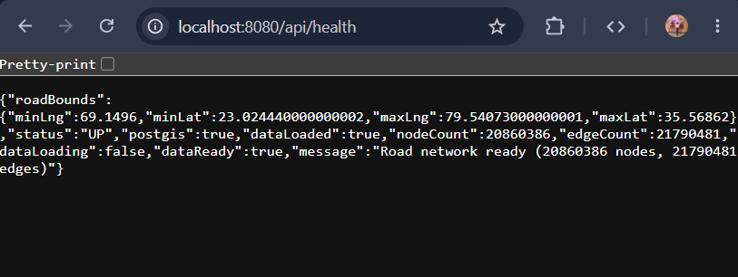
4.2 FRONTEND
The frontend of GeoRoute was developed using Angular 17 to provide an interactive and responsive user interface for offline route planning. Angular was selected because of its component-based architecture, dependency injection framework, strong TypeScript support, and efficient state management capabilities. Since the application is intended for deployment in secure and isolated environments where Internet connectivity is unavailable, all frontend libraries are installed locally using Node Package Manager (npm), eliminating the dependency on external Content Delivery Networks (CDNs). The generated production build is packaged together with the Spring Boot backend so that both the client interface and server application are executed from the same system.
The frontend is responsible for presenting the map to the user, capturing user interactions, communicating with the backend REST services, and rendering the calculated routes. Unlike the backend, it performs no routing computations. Its primary objective is to provide an intuitive interface while delegating computational tasks to the server.
The application follows Angular's component-based architecture. Each major feature is implemented as an independent component or service, improving modularity and simplifying future maintenance. Services are used for communication with the backend, while components handle presentation and user interaction.
The Angular project structure is organized into components, services, models, environments, and assets. Components manage the visual interface, services encapsulate business communication with the backend, models define the structure of data exchanged through REST APIs, and environment files store configuration values such as backend endpoints.
The Map Component serves as the central component of the frontend. It initializes the OpenLayers map, displays raster tiles received from the backend, handles user mouse clicks, places source and destination markers, requests snapping operations, displays calculated routes, and automatically adjusts the map view according to the displayed information. By concentrating all visualization logic within a single component, the application maintains a clear separation between presentation and backend processing.
The initialization process begins when Angular creates the Map Component. During initialization, the OpenLayers map object is created with several layers including the raster tile layer, vector route layer, and marker layer. The map is initially centered on India, while the backend later adjusts the visible extent according to the available road dataset.
ngOnInit(): void {
this.initMap();
this.fitToRoadData();
this.subscribeToRoutes();
this.subscribeToPins();
}
The OpenLayers library is used to display the offline map. Instead of requesting map imagery from an online provider, tile requests are sent directly to the locally running Spring Boot server. The server dynamically renders PNG image tiles from the stored GeoTIFF file and returns them to the browser. Consequently, the visualization process remains completely independent of Internet-based map services.
The tile layer is configured as follows.
new TileLayer({
source: new XYZ({
url: environment.tileUrl,
crossOrigin: 'anonymous',
maxZoom: 18,
minZoom: 4
})
})
The environment configuration file stores the backend tile endpoint. Storing URLs in environment files rather than hardcoding them throughout the application simplifies future deployment because only a single configuration file requires modification.
User interaction begins when the user clicks anywhere on the displayed map. OpenLayers converts the screen coordinates into geographic latitude and longitude values. These coordinates are then passed to the backend for nearest-road snapping rather than being used directly for routing. This design prevents routing from beginning at arbitrary locations that do not belong to the road network.
The click event is registered as follows.
this.map.on('click', (event) => {
const [lng, lat] = toLonLat(event.coordinate);
this.handleMapClick(lat, lng);
});
The handleMapClick() function communicates with the backend through the Snap Service. Depending on the current selection mode, the snapped location is stored either as the source point or the destination point. After selecting the origin, the application automatically switches into destination selection mode, reducing the number of interactions required from the user.
The frontend also performs extensive validation of backend responses. If snapping fails because no road exists within the configured search radius, the interface immediately informs the user through descriptive toast notifications. Additional error messages are displayed if the routing database is still loading, the database query times out, or unexpected server-side exceptions occur. These messages significantly improve usability because users receive meaningful explanations instead of generic failure notifications.
Once both locations have been successfully snapped to the road network, the routing request is transmitted to the backend. The request includes the snapped source node, destination node, selected routing algorithm, and the desired number of alternate routes. These values are packaged into a JSON request object and transmitted using Angular's HttpClient service.
The response returned by the backend contains one or more routes represented as ordered geographic coordinates. Each route is converted into an OpenLayers LineString geometry and added to the vector layer for visualization.
const feature = new Feature({
geometry: new LineString(coords)
});
The application supports simultaneous visualization of multiple routes. The optimal route is displayed using a thick solid blue line, while alternate routes are drawn using different colours and dashed patterns. Distinct visual styles allow users to compare several possible routes without confusion.
The route drawing procedure applies different styles dynamically according to the route index.
feature.setStyle(
new Style({
stroke: new Stroke({
color,
width: lineWidth,
lineDash
})
})
);
To improve readability, alternate routes are drawn first while the primary shortest route is rendered last. Consequently, the optimal route always appears on top of the remaining alternatives instead of being hidden beneath overlapping segments.
Marker visualization is implemented independently from route rendering. Source and destination locations are displayed as coloured circular markers positioned at the snapped road coordinates rather than the user's original mouse click. Green markers indicate the starting location while red markers represent the destination.
Marker generation is performed using OpenLayers point geometries.
new Feature({
geometry: new Point(fromLonLat([lng, lat]))
});
The application automatically redraws markers whenever the selected source or destination changes. Existing markers are removed before new ones are added, ensuring that outdated locations never remain visible on the map.
To simplify communication between multiple Angular components, a centralized MapStateService manages the application's current state. This service stores the selected source location, destination location, calculated routes, snapping status, and current interaction mode. Angular's reactive programming model allows all subscribed components to update automatically whenever these values change. As a result, manual synchronization between interface elements is unnecessary.
The frontend also performs automatic map fitting after a route has been successfully calculated. Instead of requiring the user to manually zoom or pan the map, the visible area is automatically adjusted so that the complete route becomes visible.
const extent = this.routeSource.getExtent();
this.map.getView().fit(extent, {
padding: [60, 60, 60, 60],
duration: 400,
maxZoom: 15
});
This automatic adjustment greatly improves user experience because even long-distance routes spanning large geographic regions remain immediately visible after computation.
In addition to routing visualization, the frontend also queries the backend health endpoint during application startup. The returned dataset contains the geographic extent of the currently loaded road network together with the number of imported road segments. If only a small regional dataset is available instead of the complete national dataset, the frontend automatically zooms to the available area and informs the user that routing is limited to that region. This prevents confusion when testing with smaller extracts during development.
The application was designed to operate entirely offline. Angular libraries, OpenLayers, fonts, JavaScript dependencies, and style resources are stored locally within the project. During deployment, the Angular production build is generated using the Angular CLI and copied into the Spring Boot static resources directory. Consequently, both the frontend and backend execute from a single server instance, simplifying installation in isolated environments.
The frontend implementation emphasizes usability, responsiveness, and modular software engineering principles. Angular's component architecture, combined with OpenLayers' GIS visualization capabilities and reactive state management, provides an efficient interface for offline route planning. By separating visualization responsibilities from routing logic, the frontend remains lightweight while allowing the backend to perform computationally intensive GIS processing. This architecture improves maintainability, simplifies future feature additions, and provides a reliable user experience suitable for offline geographic information systems.

5. RESULT AND ANALYSIS
The GeoRoute application was successfully developed as a fully offline web-based mapping and routing system capable of visualizing a natural-colour basemap, importing India's road network, snapping user-selected locations to nearby roads, and computing optimal routes without relying on any external internet services. The completed system satisfies the primary objective of operating entirely through locally available software components and datasets after a one-time installation.
Testing was performed on the complete application by evaluating individual modules as well as the integrated system. The backend services were verified by checking successful database initialization, road network import, GeoTIFF loading, tile generation, nearest-road snapping, and shortest path computation. The frontend was tested by interacting with the map, placing source and destination markers, requesting routes using different algorithms, and displaying multiple alternate paths.
The GeoTIFF tile rendering service successfully generated map tiles from the locally stored raster image. As the user zoomed and panned across the map, new tiles were produced dynamically without contacting any external tile server. Frequently accessed tiles were retrieved from the local cache, resulting in noticeably faster rendering during repeated navigation.
The Shapefile import process correctly converted the road network into nodes and edges stored within the PostGIS database. The imported data provided the routing graph used by the application. Once the import process completed successfully, the application remained ready for future executions without requiring repeated data loading unless the database was reset.
The nearest-road snapping mechanism demonstrated accurate behaviour by projecting selected map locations onto nearby road segments before routing. This ensured that routes always began and ended on valid road network nodes rather than arbitrary geographical coordinates. The use of PostGIS spatial indexing significantly reduced search time, even when working with a large national road dataset.
The routing module successfully generated the shortest route between user-selected locations using both Dijkstra's algorithm and the A* algorithm. For shorter routes, all nearby roads were included within the routing subgraph, allowing detailed local navigation. For longer routes, the application initially prioritised major roads and highways before expanding the search when necessary. This adaptive strategy reduced memory consumption while maintaining routing accuracy.
When multiple routes were requested, Yen's K-Shortest Paths algorithm generated valid alternative routes in addition to the optimal path. These alternate routes followed different road segments where possible while remaining practical for navigation. Each route was displayed separately on the map using distinct colours, allowing users to compare available travel options visually.
Throughout testing, the application maintained complete offline functionality. After the initial installation of software dependencies and geographical datasets, no internet connection was required for map rendering, database operations, routing, or frontend interaction. This confirms that the application satisfies one of its most important design requirements.
The modular architecture also simplified testing and debugging. Since controllers, services, repositories, and frontend components were separated into independent modules, individual features could be tested without affecting unrelated parts of the application. Error handling mechanisms successfully reported situations such as unavailable road data, missing nearby roads, or incomplete database initialization through meaningful messages returned to the frontend.
Although the application performed successfully, several limitations were observed. Route quality depends directly on the completeness and accuracy of the imported road network. Outdated or incomplete geographical datasets may reduce routing accuracy in some regions. Similarly, the current implementation estimates travel time primarily using road length and speed limits rather than incorporating dynamic traffic conditions, since the application is designed to function entirely offline. Finally, generating routes across extremely large geographical areas increases database query time and memory usage despite the optimisation techniques implemented within the routing service.
Overall, the experimental results demonstrate that GeoRoute provides accurate offline map visualization and route computation while maintaining acceptable performance on standard desktop hardware. The implemented optimisation techniques, including subgraph construction, nearest-road snapping, tile caching, and adaptive routing corridors, contribute significantly to the efficiency and responsiveness of the application.
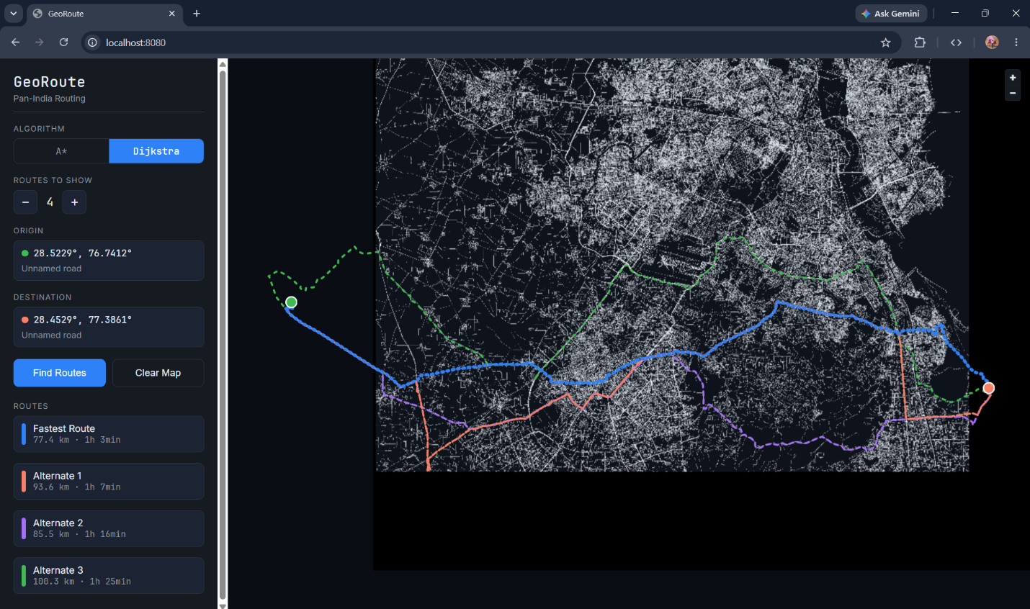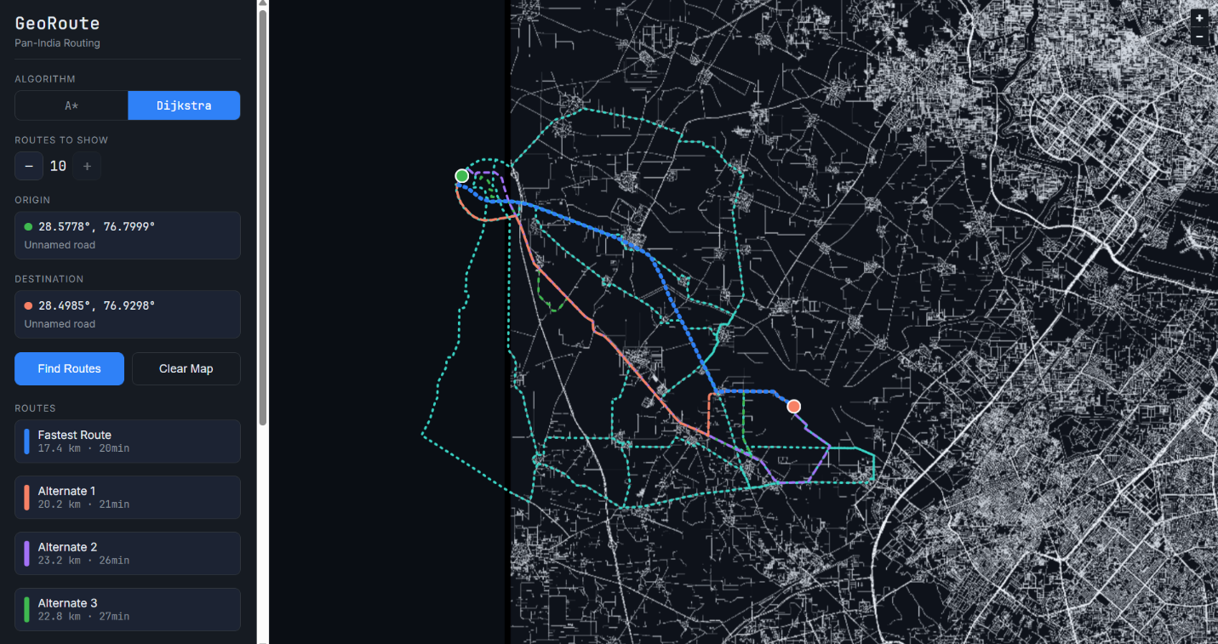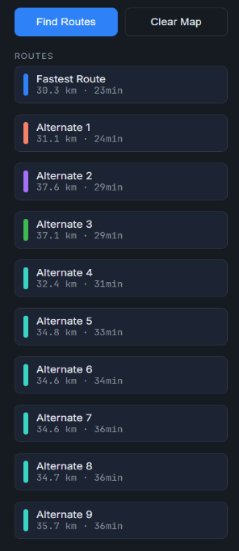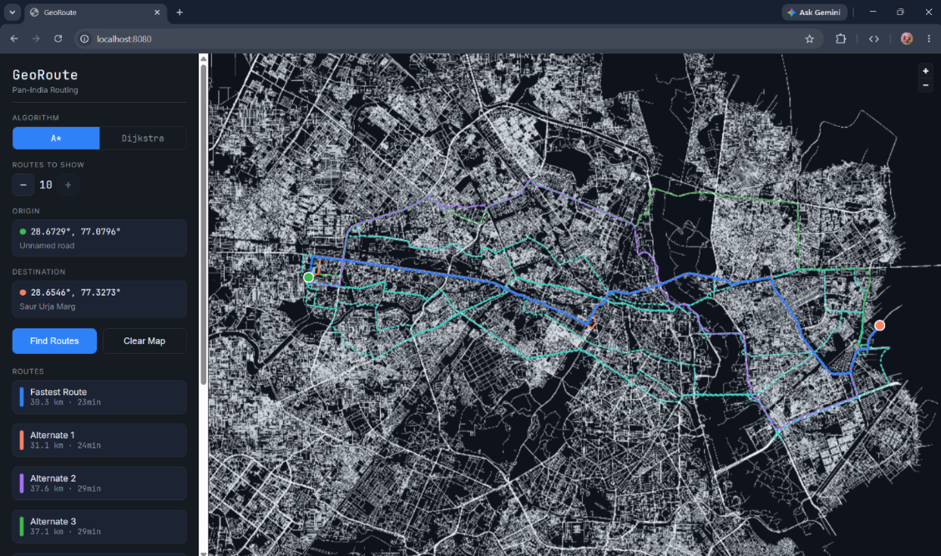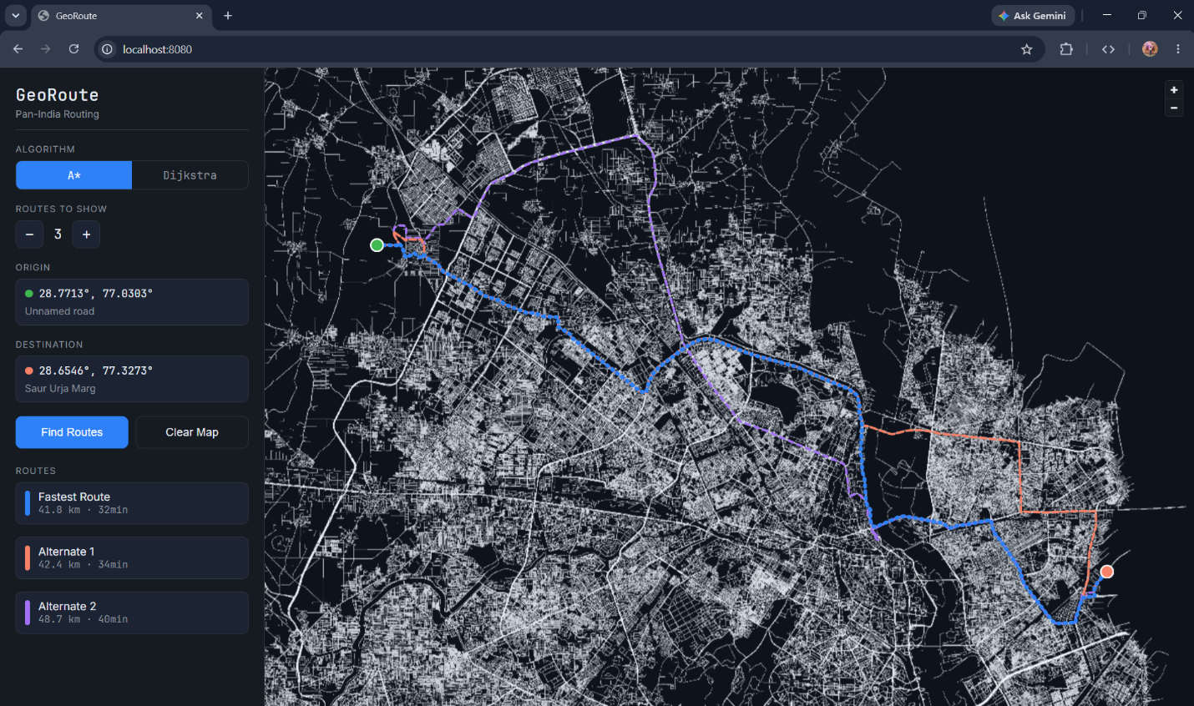

6. CONCLUSION AND FUTURE PROSPECTS
6.1 Conclusion
GeoRoute was developed to provide a completely offline mapping and routing solution capable of operating without any dependency on external internet services. The application integrates Angular, Spring Boot, PostgreSQL, PostGIS, GeoTools, and OpenLayers into a unified system that performs map visualization, nearest-road snapping, and shortest path computation entirely on the local machine.
The project successfully demonstrates that modern web-based Geographic Information Systems can be implemented without relying on cloud-hosted APIs or commercial mapping platforms. By using locally stored GeoTIFF imagery and Shapefile datasets, the application provides interactive map visualization while ensuring that all geographical information remains available even in isolated environments.
The routing engine efficiently computes shortest paths using the A* algorithm while supporting alternative route generation through Yen's K-Shortest Paths algorithm. Performance improvements such as dynamic subgraph construction, selective road loading, tile caching, and spatial indexing enable the application to process large geographical datasets without requiring excessive computational resources.
The modular architecture adopted during development improves code maintainability and supports future expansion of the system. Individual components such as tile rendering, routing, snapping, and database management remain independent, allowing additional functionality to be incorporated with minimal modification to the existing codebase.
The project achieves its primary objectives of providing an interactive offline map, importing large road datasets, accurately snapping user-selected locations to nearby roads, generating shortest and alternate routes, and operating entirely through locally available software and datasets. Consequently, GeoRoute represents a practical solution for navigation in secure environments where internet connectivity is unavailable or prohibited.
6.2 Future Prospects
Although the current implementation satisfies its intended objectives, several enhancements can further improve the application's functionality and performance.
Future versions of the application can incorporate turn-by-turn navigation with detailed driving instructions generated directly from the computed routes. This would provide users with a more complete navigation experience while maintaining offline operation.
Support for additional routing preferences could also be introduced. Users may be allowed to avoid toll roads, highways, ferries, or unpaved roads, enabling more personalised route selection according to individual travel requirements.
The routing engine can be extended to support multiple transportation modes such as walking, cycling, and emergency vehicle routing by assigning different traversal costs to road categories.
Further optimisation techniques may be implemented to improve routing performance across extremely large geographical areas. Hierarchical graph structures, contraction hierarchies, or preprocessing-based routing algorithms could significantly reduce computation time while maintaining routing accuracy.
The application may also support incremental map updates, allowing newly released road network datasets to be imported without rebuilding the entire routing database. This would simplify long-term maintenance and ensure that geographical information remains current.
Three-dimensional terrain visualisation and elevation-aware routing represent another possible extension, particularly for mountainous regions where slope significantly influences travel time.
Finally, the application could be adapted for deployment within government organisations, disaster management systems, military environments, and remote industrial facilities where secure offline navigation is essential. Because the system does not depend on external communication networks, it is well suited for environments where privacy, reliability, and operational independence are critical.
REFERENCES
- Open Geospatial Consortium (OGC). OpenGIS® Implementation Standard for Geographic Information Systems. Available at: https://www.ogc.org
- PostgreSQL Global Development Group. PostgreSQL Documentation. Available at: https://www.postgresql.org/docs/
- PostGIS Project Steering Committee. PostGIS Documentation. Available at: https://postgis.net/documentation/
- Spring. Spring Boot Reference Documentation. Available at: https://docs.spring.io/spring-boot/docs/current/reference/html/
- Angular Team. Angular Documentation. Available at: https://angular.dev
- OpenLayers Contributors. OpenLayers Documentation. Available at: https://openlayers.org
- GeoTools Project. GeoTools User Guide. Available at: https://docs.geotools.org
- Hart, P. E., Nilsson, N. J., & Raphael, B. (1968). A Formal Basis for the Heuristic Determination of Minimum Cost Paths. IEEE Transactions on Systems Science and Cybernetics, 4(2), 100–107.
- Dijkstra, E. W. (1959). A Note on Two Problems in Connexion with Graphs. Numerische Mathematik, 1(1), 269–271.
- Yen, J. Y. (1971). Finding the K Shortest Loopless Paths in a Network. Management Science, 17(11), 712–716.
- ESRI. ESRI Shapefile Technical Description. Environmental Systems Research Institute.
- Snyder, J. P. (1987). Map Projections – A Working Manual. U.S. Geological Survey Professional Paper 1395.

